

PROJECT REPORT ON

“iBook”

Submitted in the partial fulfillment of requirement for the

VI semester project

BACHELOR OF COMPUTER APPLICATIONS

ACADEMIC YEAR 2021-2022

BY

Hosam Abuelgasim (R1916609)

UNDER THE GUIDANCE OF

Prof. Abhinandan Chivate

DEPARTMENT OF COMPUTER SCIENCE

NOBLE SCHOOL OF BUSINESS

#12A/19, 9th Cross, OppRajshekar Hospital,J. P. Nagar I Phase, Bangalore – 560078

DEPARTMENT OF COMPUTER SCIENCE

NOBLE SCHOOL OF BUSINESS

#12A/19, 9th Cross, OppRajshekar Hospital, J. P. Nagar I Phase, Bangalore – 560078



CERTIFICATE

This is to certify that the project work entitled “iBook“ has been successfully completed by, Hosam Abuelgasim (R1916609), student of Noble School of Business college, J. P. Nagar, Bangalore – 78 in partial fulfillment of the requirement for VI semester of BCA course of Bangalore City University for the year 2021-2022.

Prof. Abhinandan Chivate Prof. M. Dinesh Babu

(Internal Guide) HOD

Dept. of Computer Science (Noble School of Business)

TABLE OF CONTENTS

|  |  |  |
| --- | --- | --- |
| **Sl.No.** | **TOPIC** | **PAGE No.** |
| 1 | Acknowledgement |  |
| 2 | Synopsis |  |
| 3 | System Specifications |  |
| 4 | Introduction |  |
| 5 | ER Diagram (Entity Relationship Diagram) |  |
| 6 | DFD (Data Flow Diagram) |  |
| 7 | Project Plan |  |
| 8 | Screen Shots |  |
| 9 | Source Code |  |
| 10 | Testing |  |
| 11 | Conclusion |  |
| 12 | Bibliography |  |

**ACKNOWLEDGEMENT:**

Perseverance, inspiration and motivation have always played a key role in success of any venture. In the present world of competition there is a race of existing in which those who are having willed to come forward succeed. Project is like a bridge between theoretical and practical working. With willing we join this particular project.

To design and compare a project report is very laborious work, which no student complete without taking any help from any professional.

First of all, we would like to thank the supreme power of almighty God who is obviously the one who has always guided us to work on right path of our life.

We express our deep gratitude to our guide for his invaluable guidance during the project. His unlimited guidance, innovative ideas and tireless efforts helped along the way in completing the project. We are also thankful to the staff members for their encouragement and cooperation in this successful completion of our project.

In the end we would like to thank our parents whom greatly indebted for having us brought us love and encouragement of this stage.

Project Synopsis

1. Introduction of the project
2. Objectives of the project
3. Scope of the project
4. Existing system
5. Current problems
6. Proposed system
7. Software and hardware requirement of the project
8. Future scope of the project
9. Conclusion
10. Reference or Bibliography

Introduction:

My project title is Hotel Management System.I have tried my best to make the complicated process of Hotel Management System as simple as possible using Structured & Modular technique & Menu oriented interface. I have tried to design the Project in such a way that user may not have any difficulty in using this package & further expansion is possible without much effort. Even though I cannot claim that this work to be entirely exhaustive, the main purpose of my exercise is perform each Employee’s activity in computerized way rather than manually which is time consuming.

I am confident that this software package can be readily used by non-programming personal avoiding human handled chance of error. This project is used by two types of users.

1. Online Users
2. Administrator (management of the Hotel).

Online users can see the required articles or news Administrator can maintain daily updates in the hotel records. Administrator is must be an authorized user. He can further change the password. There is the facility for password recovery, logout etc.

**PURPOSE AND MOTIVATION:**

The main purpose of this vision document is to list the requirements of the Hotel Management project. This document also helps us to collect and analyze the ideas gathered for the project. This vision document will be subject to change, if more requirements are added to the project. This document is mainly prepared to set stage for the design phase of the project. The document being prepared is the first version of vision document for the Hotel Management project.

**Javascript** is a new technology which is being used a lot in the IT field. My interest to learn this new technology has prompted me to take up this project, which would set the stage for the applications I would be developing in the future.

**PROJECT OVERVIEW**

The Hotel Management project is an implementation of a general Hotel booking application, which helps the administrator to search the availability of various hotel rooms. This project also covers various features like registration of the users, modifying the details of the application by the management staff or administrator , by adding, deleting or modifying the customer details, flights information.

**OVERALL PRODUCT DESCRIPTION**

PRODUCT PERSPECTIVE:

The Hotel Management project uses the .NET framework 4.0 and is completely independent. The project itself is a bigger product and does not need to be introduced into a larger system. The application would be running on a Windows Operating system.

**Product features:**

**The Hotel Management has the following features:**

This project is mainly intended for two types of audiences. One is the customer or the end user and the other is the administrator of the application. Some of the major functions of the product can be categorized under two different categories that are for the administrator and the user.

**Customer / End user activities**

**Customer use case diagram**

The E-R use case diagram depicts all the functions or activities that a user or a customer can perform on the application. They can be discussed in detail as follows:

**Home Page:** Like all the other hotel websites available online, the user can access the user home page of the Hotel Reservation System, after he logs into the system. Here, he can look up information regarding flights.

**Login and Register:** The Hotel Management also comes with the customer registration details page, where the customer can enter his details and register.

**Booking** **Rooms**: The customer can also search for the rooms available and reserve his place for the room by booking it.

**Advantages**:

* The advantages of booking a hotel online add up long before your arrival. Our legendary customer service extends to the web.
* One advantage of booking with the hotel directly is the use of the hotel's full cancellation policy as well as not needing a deposit in most situations.
* Read reviews and compare prices for Online Hotel Booking.
* The most important advantage of online hotel booking is convenience, you can book your room by simply sitting in home. Internet helps you to browse through the hotels around the world and compare the facilities and rates easily.

**Scope:**

Existing System with Limitations:

In this step, we provide a detailed description about the existing system and the problems faced in the existing system. This stage there is no existing system previously; we are developing a new system. Till now no system is available with this type of features and facilities. This system is developed for the all types of users with highly flexible and configurable product is envisaged to ensure global marketing.

Proposed System Features:

* Some of the service providers won't allow you to choose your hotel, they only allow you to select location and quality of the hotel. Considerable discounts on hotels may be available in off-seasons.
* Utilize the serve of online hotel booking service providers when you are planning for a trip
* Each and every customer looks to book their hotel rooms early and conveniently.
* User can Post, update and delete the links in the all categories.
* Online hotel booking is the best ways to book rooms in your favourite hotels.
* Planning a vacation has never been easier and more reasonable than now. Easiness, affordable pricing, and simple comparison shopping make online hotel bookings accepted to all.

**SPECIFICATION REQUIREMENT**

Requirement analysis for web applications encompasses three major tasks: formulation, requirements gathering and analysis modeling. During formulation, the basic motivation and goals for the web application are identified, and the categories of users are defined. In the requirements gathering phase, the content and functional requirements are listed and interaction scenarios written from end-user’s point-of-view are developed. This intent is to establish a basic understanding of why the web application is built, who will use it, and what problems it will solve for its users.

Software requirement Specification:

A set of programs associated with the operation of a computer is called software. Software is the part of the computer system, which enables the user to interact with several physical hardware devices.

The minimum software requirement specifications for developing this project are as follow:

Operating system : windows / linux / macOs

Runtime environment : node.js

Back-end development : express.js

Front-end development: react.js

Style-sheet : css / scss / material Ui

Database : mongoDB

Code editor : visual studio code

Documentation tools : ms office

**Hardware Requirement Specification:**

The collection of internal electronic circuits and external physical devices used in building a computer is called the Hardware.

The minimum hardware requirement specifications for developing this project are as follows:

**Processor** : **standard processor with a speed of 1.6 GHz**

**RAM : 256 mb RAM or more**

**Hard disk : 20 GB or more**

**Monitor : standard color monitor**

**Keyboard : standard keyboard**

**Mouse : standard mouse**

**Module Description:**

The HOTEL MANAGEMENT SYSTEM consists of 2 modules and 5 categories. The categories are as follows:

1. Advance search
2. Booking
3. Hotels filter
4. Payment

The modules are:

1. Admin
2. User

**Admin module:**

**The Functionalities of the Administrator is:**

1. The administrator should login into the system with unique his/her password and username. 2. If the username and password is validated then he can gain access to the system.

3. View the hotels can update and delete the hotels.

4. Post the special offers, add new hotel to the hotels list.

5. Insert /View the Availability and Price.

6. Post the links. Adding the links to the hotels and as well view the links.

7. Blocks the user view the status of the users.

8. Restrict the user to the see the more information with out login.

**The administrator can do the following actions:**

1. Login
2. Change password
3. Admin functionality
4. View hotles.
5. Add hotel.
6. Post offers.
7. Delete / edit / update hotels.
8. Upload images.

**User module:**

**The functionalities of the user are:**

1. A new User can register with the application by entering his appropriate details.

2. The User should login into the system with unique his/her password and username.

3. If the username and password is validated then he can gain access to the system.

4. The User can change his password, To change the password, it should ask for the old password, new password and confirm new password

5. View the Categories.

**The user can do the following actions:**

1. Register
2. Login
3. Change password
4. logout
5. User funcionalties
6. Booking
7. Advance search
8. Payment
9. Mission & Vision:

Our Mission is to measurably improve our client’s planning, operations, finances, marketing and services outcomes by demonstrating outstanding performance standards while providing cost effective consulting and professional services. To become IT partner to fortune companies for providing information management services.

“In order to realize our Vision, our Mission must be to exceed the expectations of our customers, whom we define as partners and fellow employees.” We will accomplish this by committing to our shared values and by achieving the highest levels of customer satisfaction, with extraordinary emphasis on the creation of value

**SOFTWARE DEVELOPMENT METHODOLOGY**

The methodology used to develop this project is object-oriented methodology is based on function and procedures. It can be said as the development of software by building self-contained modules as objects that can be easily replaced, modified and reused. In this environment software is a collection of discrete objects that encapsulate their data as well as the functionality to model real world “objects”. Each object has attribute and methods. Objects are grouped into classes. Here each object is responsible for itself.

This environment emphasizes its cooperative philosophy by allocating tasks among the objects of the applications. Instead of writing a lot of code we can create a lot of code we can create a lot of helps to take in an active role.

Object oriented methodology involves mainly:

1. Analysis

2. Design

3. Prototyping and testing.

Analysis

There are 5 important steps in the analysis. They are

1. Identification of the users/actors.

2. Development a simple business process model.

3. Developing the use cases.

4. Developing the interaction diagrams.

5. Classifications.

**OBJECTIVES:**

During the past several decades personnel function has been transformed from a relatively obscure record keeping staff to central and top level management function. There are many factors that have influenced this transformation like technological advances, professionalism, and general recognition of human beings as most important resources.

* A computer based management system is designed to handle all the primary information required to calculate monthly statements. Separate database is.
* Maintained to handle all the details required for the correct statement calculation and generation.
* This project intends to introduce more user friendliness in the various activities such as record updation, maintenance, and searching.
* This project intends to introduce more user friendliness in the various activities such as record updation, maintenance, and searching.
* Similarly, record maintenance and updation can also be accomplished by using the identification of the customer with all the details being automatically generated. These details are also being promptly automatically updated in the master file thus keeping the record absolutely up-to-date.
* The entire information has maintained in the database or Files and whoever wants to retrieve can’t retrieve, only authorization user can retrieve the necessary information which can be easily be accessible from the file.

**TECHNOLOGIES USED:**

MERN stack technologies:

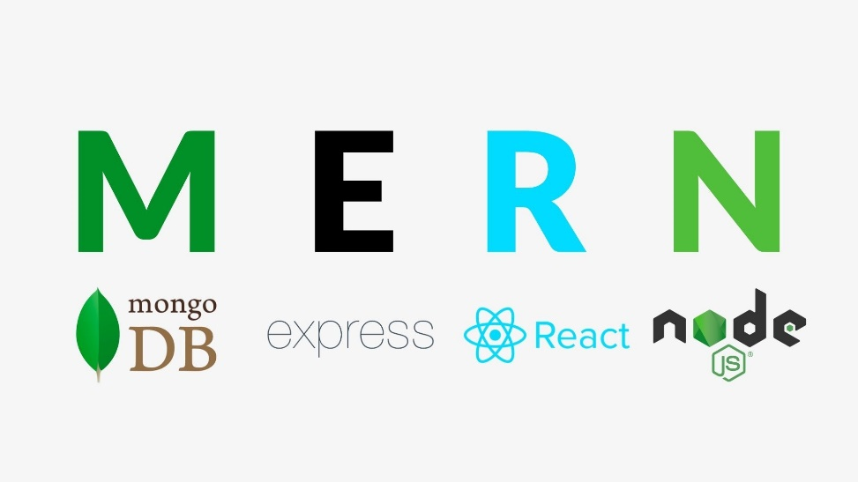

**MERN** stack is a software stack that includes four open-source technologies: (MongoDB, Express.js, React, and Node.js). These components provide an end-to-end framework for building dynamic web sites and web applications.

Among these technologies MongoDB is a database system, Node.js is a server-side runtime environment, Express.js is a web framework for Node.js and React is a client-side JavaScript library used for building user interfaces.

Because all components of the MERN stack support programs that are written in JavaScript, MERN applications can be written in one programming language for both server-side and client-side execution environments.

Javascript:



**Javascript** often abbreviated **JS**, is a programming language that is one of the core technologies of the world wide web alongside HTML an CSS As of 2022, 98% of [websites](https://en.wikipedia.org/wiki/Website) use JavaScript on the [client](https://en.wikipedia.org/wiki/Client_(computing)) side for [webpage](https://en.wikipedia.org/wiki/Web_page) behavior,[[12]](https://en.wikipedia.org/wiki/JavaScript#cite_note-deployedstats-12) often incorporating third-party [libraries](https://en.wikipedia.org/wiki/Library_(computing)).[[13]](https://en.wikipedia.org/wiki/JavaScript#cite_note-lib_usage-13) All major [web browsers](https://en.wikipedia.org/wiki/Web_browser) have a dedicated [JavaScript engine](https://en.wikipedia.org/wiki/JavaScript_engine) to execute the [code](https://en.wikipedia.org/wiki/Source_code) on [users](https://en.wikipedia.org/wiki/User_(computing))' devices.

JavaScript is a [high-level](https://en.wikipedia.org/wiki/High-level_programming_language), often [just-in-time compiled](https://en.wikipedia.org/wiki/Just-in-time_compilation) language that conforms to the [ECMAScript](https://en.wikipedia.org/wiki/ECMAScript) standard.[[14]](https://en.wikipedia.org/wiki/JavaScript#cite_note-tc39-14) It has [dynamic typing](https://en.wikipedia.org/wiki/Dynamic_typing), [prototype-based](https://en.wikipedia.org/wiki/Prototype-based_programming) object-orientation, and [first-class functions](https://en.wikipedia.org/wiki/First-class_function). It is [multi-paradigm](https://en.wikipedia.org/wiki/Programming_paradigm), supporting [event-driven](https://en.wikipedia.org/wiki/Event-driven_programming), [functional](https://en.wikipedia.org/wiki/Functional_programming), and [imperative](https://en.wikipedia.org/wiki/Imperative_programming) [programming styles](https://en.wikipedia.org/wiki/Programming_paradigm). It has [application programming interfaces](https://en.wikipedia.org/wiki/Application_programming_interface) (APIs) for working with text, dates, [regular expressions](https://en.wikipedia.org/wiki/Regular_expression), standard [data structures](https://en.wikipedia.org/wiki/Data_structure), and the [Document Object Model](https://en.wikipedia.org/wiki/Document_Object_Model) (DOM).

The ECMAScript standard does not include any [input/output](https://en.wikipedia.org/wiki/Input/output) (I/O), such as [networking](https://en.wikipedia.org/wiki/Computer_network), [storage](https://en.wikipedia.org/wiki/Data_storage), or [graphics](https://en.wikipedia.org/wiki/Computer_graphics) facilities. In practice, the web browser or other [runtime system](https://en.wikipedia.org/wiki/Runtime_system) provides JavaScript APIs for I/O.

JavaScript engines were originally used only in web browsers, but are now core components of some [servers](https://en.wikipedia.org/wiki/Server_(computing)) and a variety of [applications](https://en.wikipedia.org/wiki/Application_software). The most popular runtime system for this usage is [Node.js](https://en.wikipedia.org/wiki/Node.js).

Although [Java](https://en.wikipedia.org/wiki/Java_(programming_language)) and JavaScript are similar in name, [syntax](https://en.wikipedia.org/wiki/Syntax_(programming_languages)), and respective [standard libraries](https://en.wikipedia.org/wiki/Standard_library), the two languages are distinct and differ greatly in design.

**React.js:**

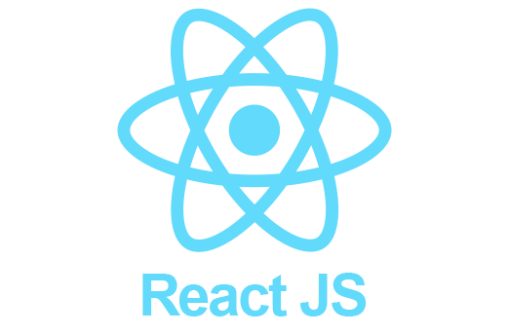

**React** (also known as **React.js** or **ReactJS**) is a [free and open-source](https://en.wikipedia.org/wiki/Free_and_open-source_software) [front-end](https://en.wikipedia.org/wiki/Front_end_and_back_end) [JavaScript library](https://en.wikipedia.org/wiki/JavaScript_library)[[3]](https://en.wikipedia.org/wiki/React_(JavaScript_library)#cite_note-react-3) for building [user interfaces](https://en.wikipedia.org/wiki/User_interfaces) based on UI components. It is maintained by [Meta](https://en.wikipedia.org/wiki/Meta_Platforms) (formerly Facebook) and a community of individual developers and companies.[[4]](https://en.wikipedia.org/wiki/React_(JavaScript_library)#cite_note-4)[[5]](https://en.wikipedia.org/wiki/React_(JavaScript_library)#cite_note-5)[[6]](https://en.wikipedia.org/wiki/React_(JavaScript_library)#cite_note-6) React can be used as a base in the development of [single-page](https://en.wikipedia.org/wiki/Single-page_application), mobile, or server-rendered applications with frameworks like [Next.js](https://en.wikipedia.org/wiki/Next.js). However, React is only concerned with state management and rendering that state to the [DOM](https://en.wikipedia.org/wiki/Document_Object_Model), so creating React applications usually requires the use of additional libraries for routing, as well as certain client-side functionality

**Node.js:**

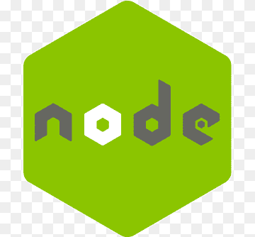

**Node.js** is an [open-source](https://en.wikipedia.org/wiki/Open-source_software), [cross-platform](https://en.wikipedia.org/wiki/Cross-platform), [back-end](https://en.wikipedia.org/wiki/Front_end_and_back_end) [JavaScript](https://en.wikipedia.org/wiki/JavaScript) [runtime environment](https://en.wikipedia.org/wiki/Runtime_system) that runs on a [JavaScript Engine](https://en.wikipedia.org/wiki/JavaScript_Engine) (i.e. [V8 engine](https://en.wikipedia.org/wiki/V8_(JavaScript_engine))) and executes JavaScript code outside a [web browser](https://en.wikipedia.org/wiki/Web_browser), which was designed to build scalable network applications. Node.js lets developers use JavaScript to write command line tools and for [server-side scripting](https://en.wikipedia.org/wiki/Server-side_scripting)—running scripts server-side to produce [dynamic web page](https://en.wikipedia.org/wiki/Dynamic_web_page) content before the page is sent to the user's web browser. Consequently, Node.js represents a "JavaScript everywhere" paradigm,[[6]](https://en.wikipedia.org/wiki/Node.js#cite_note-6) unifying [web-application](https://en.wikipedia.org/wiki/Web_application) development around a single programming language, rather than different languages for server-side and client-side scripts.

Node.js has an [event-driven architecture](https://en.wikipedia.org/wiki/Event-driven_architecture) capable of [asynchronous I/O](https://en.wikipedia.org/wiki/Asynchronous_I/O). These design choices aim to optimize [throughput](https://en.wikipedia.org/wiki/Throughput) and [scalability](https://en.wikipedia.org/wiki/Scalability) in web applications with many input/output operations, as well as for [real-time Web](https://en.wikipedia.org/wiki/Real-time_Web) applications (e.g., [real-time communication](https://en.wikipedia.org/wiki/Real-time_communication) programs and [browser games](https://en.wikipedia.org/wiki/Browser_game)).[[7]](https://en.wikipedia.org/wiki/Node.js#cite_note-readwrite-7)

The Node.js [distributed development](https://en.wikipedia.org/wiki/Distributed_development) project was previously governed by the Node.js Foundation,[[8]](https://en.wikipedia.org/wiki/Node.js#cite_note-8) and has now merged with the [JS Foundation](https://en.wikipedia.org/wiki/JS_Foundation) to form the [OpenJS Foundation](https://en.wikipedia.org/wiki/OpenJS_Foundation), which is facilitated by the [Linux Foundation](https://en.wikipedia.org/wiki/Linux_Foundation)'s Collaborative Projects program.

**Express.js:**



**Express.js**, or simply **Express**, is a [back end](https://en.wikipedia.org/wiki/Front_end_and_back_end) [web application framework](https://en.wikipedia.org/wiki/Web_application_framework) for [Node.js](https://en.wikipedia.org/wiki/Node.js), released as [free and open-source software](https://en.wikipedia.org/wiki/Free_and_open-source_software) under the [MIT License](https://en.wikipedia.org/wiki/MIT_License). It is designed for building [web applications](https://en.wikipedia.org/wiki/Web_application) and [APIs](https://en.wikipedia.org/wiki/API).[[3]](https://en.wikipedia.org/wiki/Express.js#cite_note-ExpressJS-3) It has been called the [de facto standard](https://en.wikipedia.org/wiki/De_facto_standard) server framework for [Node.js](https://en.wikipedia.org/wiki/Node.js).[[4]](https://en.wikipedia.org/wiki/Express.js#cite_note-4)

The original author, TJ Holowaychuk, described it as a [Sinatra](https://en.wikipedia.org/wiki/Sinatra_(software))-inspired server,[[5]](https://en.wikipedia.org/wiki/Express.js#cite_note-5) meaning that it is relatively minimal with many features available as plugins. Express is the back-end component of popular development stacks like the [MEAN](https://en.wikipedia.org/wiki/MEAN_(software_bundle)), MERN or MEVN stack, together with the [MongoDB](https://en.wikipedia.org/wiki/MongoDB) database software and a [JavaScript](https://en.wikipedia.org/wiki/JavaScript) front-end framework or library

**MongoDB:**



**MongoDB** is a [source-available](https://en.wikipedia.org/wiki/Source-available) [cross-platform](https://en.wikipedia.org/wiki/Cross-platform) [document-oriented database](https://en.wikipedia.org/wiki/Document-oriented_database) program. Classified as a [NoSQL](https://en.wikipedia.org/wiki/NoSQL) database program, MongoDB uses [JSON](https://en.wikipedia.org/wiki/JSON)-like documents with optional [schemas](https://en.wikipedia.org/wiki/Database_schema). MongoDB is developed by [MongoDB Inc.](https://en.wikipedia.org/wiki/MongoDB_Inc.) and licensed under the [Server Side Public License](https://en.wikipedia.org/wiki/Server_Side_Public_License) (SSPL) which is deemed non-free by several distributions.

**CSS:**

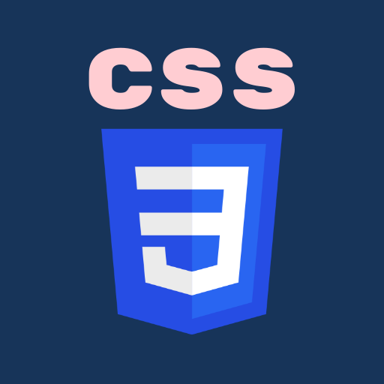

**Cascading Style Sheets** (**CSS**) is a [style sheet language](https://en.wikipedia.org/wiki/Style_sheet_language) used for describing the [presentation](https://en.wikipedia.org/wiki/Presentation_semantics) of a document written in a [markup language](https://en.wikipedia.org/wiki/Markup_language) such as [HTML](https://en.wikipedia.org/wiki/HTML) or [XML](https://en.wikipedia.org/wiki/XML) (including XML dialects such as SVG, MathML or XHTML).[[1]](https://en.wikipedia.org/wiki/CSS#cite_note-1) CSS is a cornerstone technology of the [World Wide Web](https://en.wikipedia.org/wiki/World_Wide_Web), alongside HTML and [JavaScript](https://en.wikipedia.org/wiki/JavaScript).[[2]](https://en.wikipedia.org/wiki/CSS#cite_note-2)

CSS is designed to enable the separation of presentation and content, including [layout](https://en.wikipedia.org/wiki/Page_layout), [colors](https://en.wikipedia.org/wiki/Color), and [fonts](https://en.wikipedia.org/wiki/Typeface).[[3]](https://en.wikipedia.org/wiki/CSS#cite_note-3) This separation can improve content [accessibility](https://en.wikipedia.org/wiki/Accessibility); provide more flexibility and control in the specification of presentation characteristics; enable multiple [web pages](https://en.wikipedia.org/wiki/Web_page) to share formatting by specifying the relevant CSS in a separate .css file, which reduces complexity and repetition in the structural content; and enable the .css file to be [cached](https://en.wikipedia.org/wiki/Cache_(computing)) to improve the page load speed between the pages that share the file and its formatting.

Separation of formatting and content also makes it feasible to present the same markup page in different styles for different rendering methods, such as on-screen, in print, by voice (via speech-based browser or [screen reader](https://en.wikipedia.org/wiki/Screen_reader)), and on [Braille-based](https://en.wikipedia.org/wiki/Braille_display) tactile devices. CSS also has rules for alternate formatting if the content is accessed on a [mobile device](https://en.wikipedia.org/wiki/Mobile_device).[[4]](https://en.wikipedia.org/wiki/CSS#cite_note-4)

The name *cascading* comes from the specified priority scheme to determine which style rule applies if more than one rule matches a particular element. This cascading priority scheme is predictable.

**Scss:**



**Sass** (short for ***syntactically awesome style sheets***) is a [preprocessor](https://en.wikipedia.org/wiki/Preprocessor) [scripting language](https://en.wikipedia.org/wiki/Scripting_language) that is [interpreted](https://en.wikipedia.org/wiki/Interpreted_language) or [compiled](https://en.wikipedia.org/wiki/Compiled_language) into [Cascading Style Sheets](https://en.wikipedia.org/wiki/Cascading_Style_Sheets) (CSS). SassScript is the scripting language itself.

Sass consists of two [syntaxes](https://en.wikipedia.org/wiki/Syntax_(programming_languages)). The original syntax, called "the indented syntax," uses a syntax similar to [Haml](https://en.wikipedia.org/wiki/Haml).[[2]](https://en.wikipedia.org/wiki/Sass_(stylesheet_language)#cite_note-main-2) It uses [indentation](https://en.wikipedia.org/wiki/Indent_style) to separate [code blocks](https://en.wikipedia.org/wiki/Block_(programming)) and [newline](https://en.wikipedia.org/wiki/Newline) characters to separate rules. The newer syntax, "SCSS" (Sassy CSS), uses block formatting like that of CSS. It uses braces to denote code blocks and semicolons to separate rules within a block. The indented syntax and SCSS files are traditionally given the [extensions](https://en.wikipedia.org/wiki/Filename_extension) .sass and .scss, respectively.

[CSS3](https://en.wikipedia.org/wiki/CSS#CSS_3) consists of a series of selectors and pseudo-selectors that group rules that apply to them. Sass (in the larger context of both syntaxes) extends CSS by providing several mechanisms available in more traditional [programming languages](https://en.wikipedia.org/wiki/Programming_language), particularly [object-oriented languages](https://en.wikipedia.org/wiki/Object-oriented_programming), but that are not available to CSS3 itself. When SassScript is interpreted, it creates blocks of CSS rules for various selectors as defined by the Sass file. The Sass interpreter translates SassScript into CSS. Alternatively, Sass can monitor the .sass or .scss file and translate it to an output .css file whenever the .sass or .scss file is saved.

The indented syntax is a metalanguage. SCSS is a [nested metalanguage](https://en.wikipedia.org/wiki/Metalanguage#Nested), as valid CSS is valid SCSS with the same [semantics](https://en.wikipedia.org/wiki/Semantics_of_programming_languages).

SassScript provides the following mechanisms: [variables](https://en.wikipedia.org/wiki/Variable_(programming)), [nesting](https://en.wikipedia.org/wiki/Nesting_(computing)#In_programming), [mixins](https://en.wikipedia.org/wiki/Mixin), and selector [inheritance](https://en.wikipedia.org/wiki/Inheritance_(computer_science)).

**System Study & Analysis**

PRINCIPLES OF SYSTEM ANALYSIS

1. Understand the problem before you begin to create the analysis model.

2. Develop prototypes that enable a user to understand how human machine interaction will occur.

3. Record the origin of and the reason for every requirement.

4. Use multiple views of requirements like building data, function and behavioral models.

5. Work to eliminate ambiguity

Entity relationship diagram (ERD):

**Entity – Relationship Diagram**: This depicts relationship between data objects. The attribute of each data objects noted in the entity- relationship diagram can be described using a data object description. Data flow diagram serves two purposes:

1. To provide an indication of how data are transformed as they move through the system.

2. To depict the functions that transformation the data flow.

**Data Objects:** A data object is a representation of almost any composite information that must be understood by the software. By composite information, we mean something that has a number of different properties or attributes. A data object encapsulates data only there is no reference within a data object to

**operations that act on the data:**

**Attributes:** Attributes define the properties of a data object and take on one of three different characteristics.

They can be used to:

* Name an instance of a data object
* Describe the instance
* Make a reference to another instance in the data table

**Relationships**: Data objects are connected to one another in a variety of different ways. We can define a set of object relationship pairs that define the relevant relationships.

E-R-Diagram:

Hotel

customer

Room info

room

Check-in

Room record

**Customer**

**Hotel**

Bill generation

checkout

**Room**

**Hotel**

**Customer**

**BEHAVIORAL DESCRIPTION**

**Data Flow:**

There are three types of DFD’s they are :

1. Context Level DFD

2. Top Level DFD and

3. Detailed Level DFD

Context Level DFD:

In the Context Level the whole system is shown as a single process.

• No data stores are shown.

• Inputs to the overall system are shown together with data sources (as External entities).

• Outputs from the overall system are shown together with their destinations (as External entities).

**Service :**

A Service is an intermediate component which lives inside a Server and ties one or more Connectors to exactly one Engine. The Service element is rarely customized by users, as the default implementation is simple and sufficient: service interface.

**DFD:**

Hotel management

Login management

Customer management

Room category management

booking management

System user management

**System Design**

The main focus of the analysis phase of Software development is on “What needs to be done”. The objects discovered during the analysis can serve as the framework or Design. The class’s attributes, methods and association identified during analysis must be designed for implementation language. New classes must be introduced to store intermediate results during the program execution. Emphasis shifts from the application domain o implementation and computer such as user interfaces or view layer and access layer. During analysis, we look at the physical entities or business objects in the system, that is, which players and how they cooperate to do the work of the application. These objects represent tangible elements of the business. During the Design phase, we elevate the model into logical entities, some of which might relate more to the computer domain as people or employees. Here his goal is to design the classes that we need to implement the system the difference is that, at this level we focus on the view and access classes, such as how to maintain information or the best way o interact with a user or present information.

**Design process:**

During the design phase the classes identified in object-oriented analysis Must be revisited with a shift focus to their implementation. New classes or attribute and Methods must be an added for implementation purposes and user interfaces. The object-oriented design process consists of the following activities:

1. Apply design axioms to design classes, their attributes, methods, associations, structure And protocols Refine and complete the static UML class diagram by adding details to the UML diagram. This step consists of following activities. *Refine attributes *Design methods and protocols by utilizing a UML activity diagram to represent the method’s algorithms.

*Refine associations between classes

*Refine class hierarchy and design with inheritance

*Iterate and refine again

1. **Design the access layer**

• Create mirror classes: For every business class identified and created. For example, if there are three business classes, create three access layer classes.

• Identify access layer class relationships.

• Simplify classes and their relationships: The main goal here is to eliminate redundant classes and structures.

*Redundant classes: Do not keep two classes that perform similar translate results activities. Simply select one and eliminate the other.

*Method classes: Revisit the classes that consist of only one or two methods to see if they can be eliminated or combined with existing classes.

• Iterate and refine again. Define the view layer classes

• Design the macro level user interface, identifying view layer objects.

• Design the micro level user interface, which includes these activities:

* Design the view layer objects by applying the design axioms and corollaries.

* Built a prototype of the view layer interface.

• Test usability and user satisfaction

• Iterate and refine.

1. Iterate refine the whole design process. From the class diagram, you can begin to extrapolate which classes you will have to built and which existing classes you can reuse. As you do this, also begin this, also begin thinking about the inheritance structure. If you have several classes that seem relates but have specific differences.

Design also must be traceable across requirements, analysis, design from the Requirements model.

**TESTING AND IMPLEMENTATION**

**Testing:**

**• Testing Methodologies**

* Black box testing
* White box testing
* Gray box testing

**• Levels of Testing**

* Unit testing
* Module testing
* Integration testing
* System testing
* User acceptance testing

• **Types Of Testing**

* Smoke testing
* Sanitary testing
* Regression testing
* Re-Testing
* Static testing
* Dynamic testing
* Alpha-Testing
* Beta-Testing
* Monkey testing
* Compatibility testing
* Installation testing
* Adhoc testing
* Exit…

**TCD (Test Case Documentation) :**

**STLC:**

* Test planning
* Test development
* Test execution
* Result analysis
* Bug-Tracing
* Reporting

**Testing:**

• The process of executing a system with the intent of finding an error.

• Testing is defined as the process in which defects are identified, isolated, subjected for rectification and ensured that product is defect free in order to produce the quality product and hence customer satisfaction.

• Quality is defined as justification of the requirements

• Defect is nothing but deviation from the requirements

• Defect is nothing but bug.

• Testing --- The presence of bugs

• Testing can demonstrate the presence of bugs, but not their absence

• Debugging and Testing are not the same thing!

• Testing is a systematic attempt to break a program or the AUT

• Debugging is the art or method of uncovering why the script /program did not execute properly.

**Testing Methodologies:**

• **Black box Testing:** is the testing process in which tester can perform testing on an application without having any internal structural knowledge of application. Usually Test Engineers are involved in the black box testing.

• **White box Testing:** is the testing process in which tester can perform testing on an application with having internal structural knowledge. Usually The Developers are involved in white box testing.

• **Gray Box Testing:** is the process in which the combination of black box and white box techniques are used.

**Levels of Testing:**

**Test Planning:** **1.**Test Plan is defined as a strategic document which describes the procedure how to perform various testing on the total application in the most efficient way.

**2.** Objective of testing,

**3.** Areas that need to be tested,

**4.** Areas that should not be tested,

**5.** Scheduling Resource Planning,

**6.** Areas to be automated, various testing tools used

**Test Development:** **1.** Test case Development (check list)

**2.**Test Procedure preparation. (Description of the test cases)

**Test Execution**: **1.** Implementation of test cases. Observing the result.

**Result Analysis:** **1.** Expected value: is nothing but expected behavior Of application.

**2**.Actual value: is nothing but actual behavior of the application

**Bug Tracing:** Collect all the failed cases, prepare documents.

**Reporting:** Prepare document (status of the application)

**Types Of Testing:**

• **Smoke Testing:** is the process of initial testing in which tester looks for the availability of all the functionality of the application in order to perform detailed testing on them. (Main check is for available forms)

• **Sanity Testing:** is a type of testing that is conducted on an application initially to check for the proper behavior of an application that is to check all the functionality are available before the detailed testing is conducted by on them.

• **Regression Testing:** is one of the best and important testing. Regression testing is the process in which the functionality, which is already tested before, is once again tested whenever some new change is added in order to check whether the existing functionality remains same.

• **Re-Testing:** is the process in which testing is performed on some functionality which is already tested before to make sure that the defects are reproducible and to rule out the environments issues if at all any defects are there.

• **Static Testing**: is the testing, which is performed on an application when it is not been executed. ex: GUI, Document Testing

• **Dynamic Testing:** is the testing which is performed on an application when it is being executed. ex: Functional testing.

• **Alpha Testing:** it is a type of user acceptance testing, which is conducted on an application when it is just before released to the customer.

• **Beta-Testing:** it is a type of UAT that is conducted on an application when it is released to the customer, when deployed in to the real time environment and being accessed by the real time users.

• **Monkey Testing:** is the process in which abnormal operations, beyond capacity operations are done on the application to check the stability of it in spite of the users abnormal behavior.

• **Compatibility testing:** it is the testing process in which usually the products are tested on the environments with different combinations of databases (application servers, browsers…etc) In order to check how far the product is compatible with all these environments platform combination.

• **Installation Testing:** it is the process of testing in which the tester try to install or try to deploy the module into the corresponding environment by following the guidelines produced in the deployment document and check whether the installation is successful or not.

**Adhoc Testing:** Adhoc Testing is the process of testing in which unlike the formal testing where in test case document is used, with out that test case document testing can be done of an application, to cover that testing of the future which are not covered in that test case document. Also it is intended to perform GUI testing which may involve the cosmotic issues

**Output Screens**

To start the iBook server we have to open the windows CMD and the navigate to the api folder which contains the back-end server code , the we give the command **npm start** which will start our server

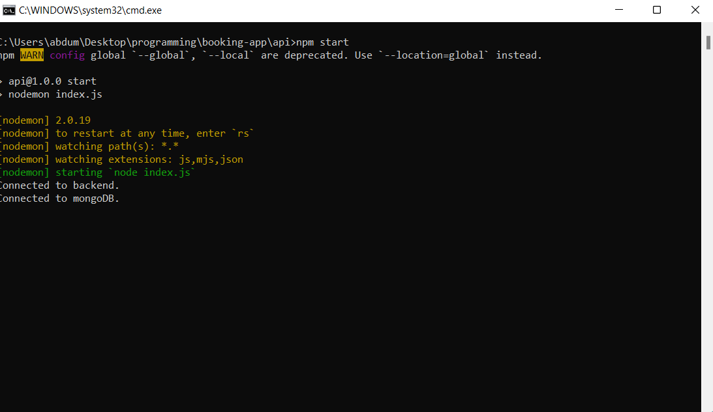

**Starting the admin dashboard**

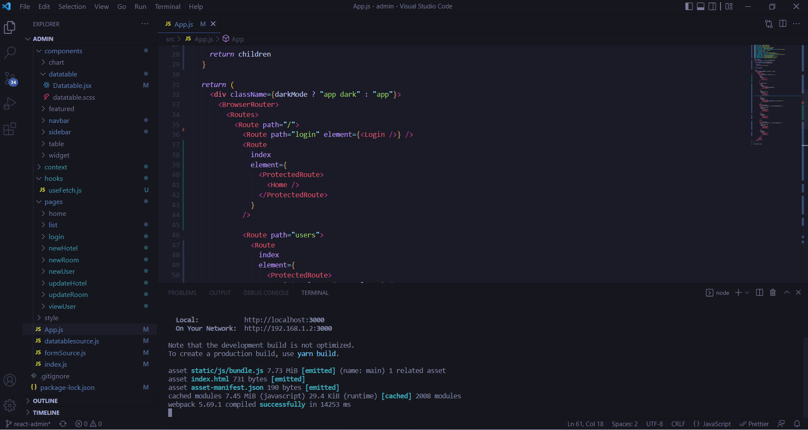

**Admin login page**

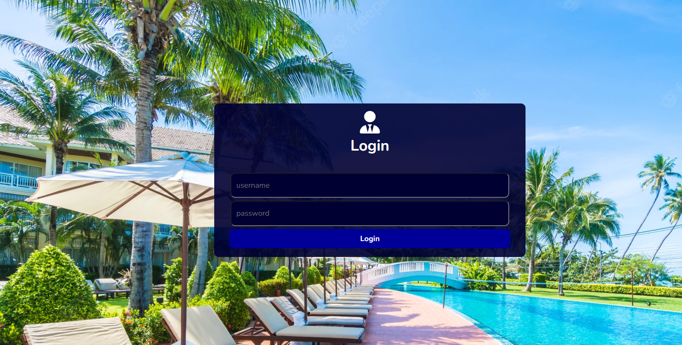

**Admin login Authorization**

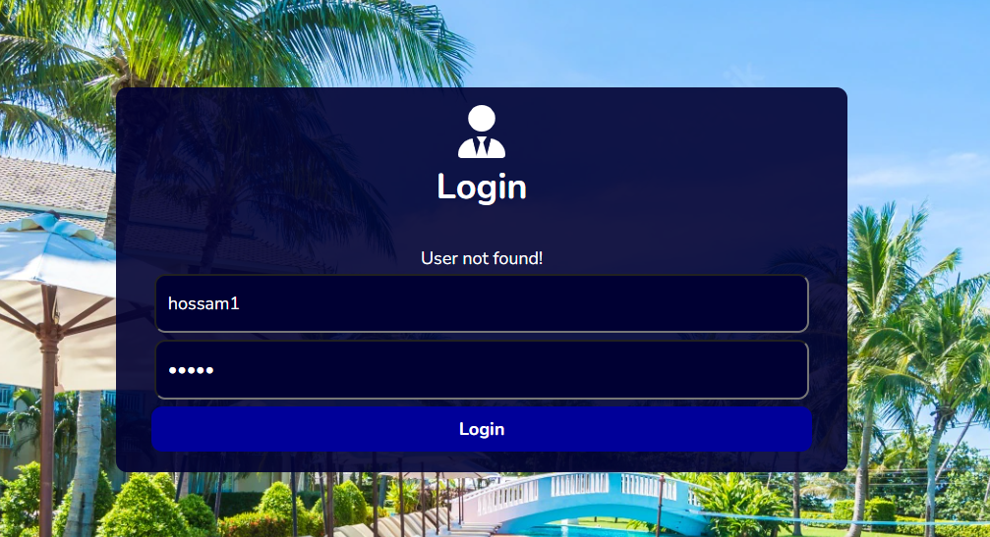

**Admin login Authorization**

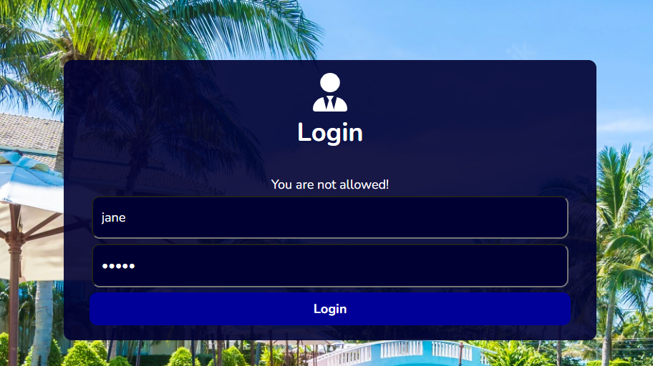

**Admin Dashboard**

**Home page**

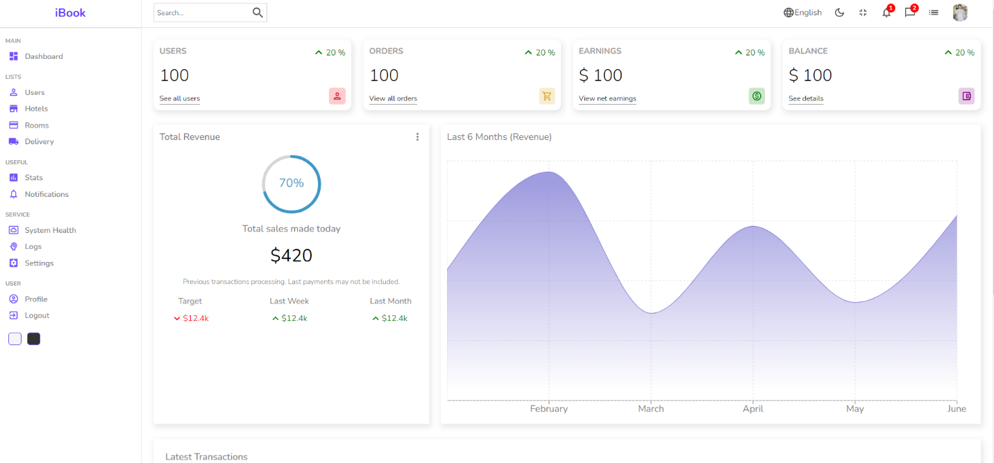

**Admin Dashboard**

**Users page**

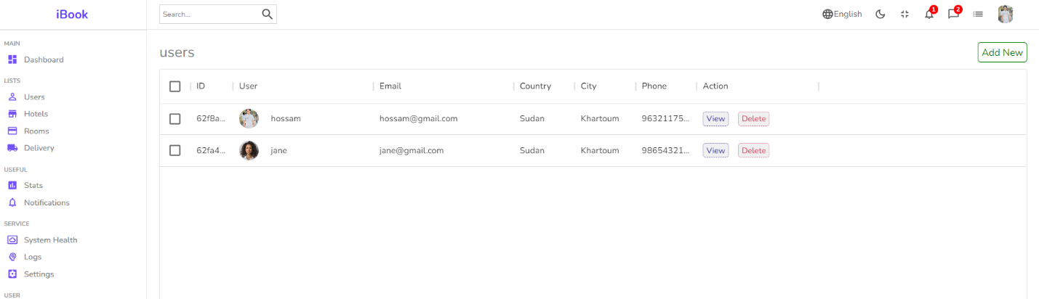

**Admin Dashboard**

**View user**

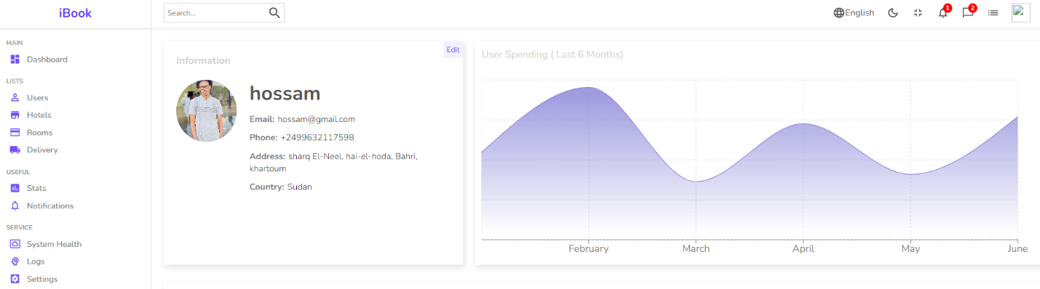

**Admin Dashboard**

**Add New User**

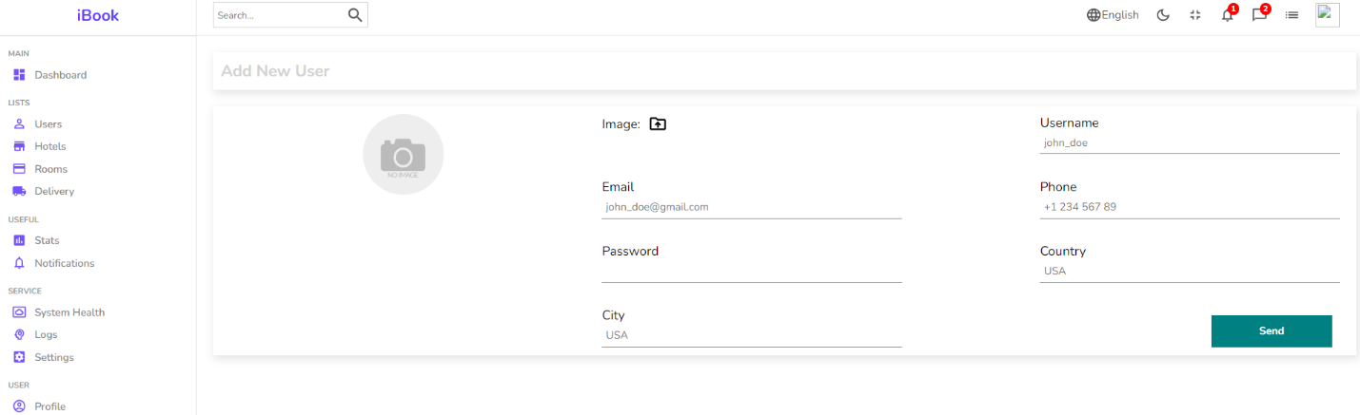

**Admin Dashboard**

**Dark Mode**

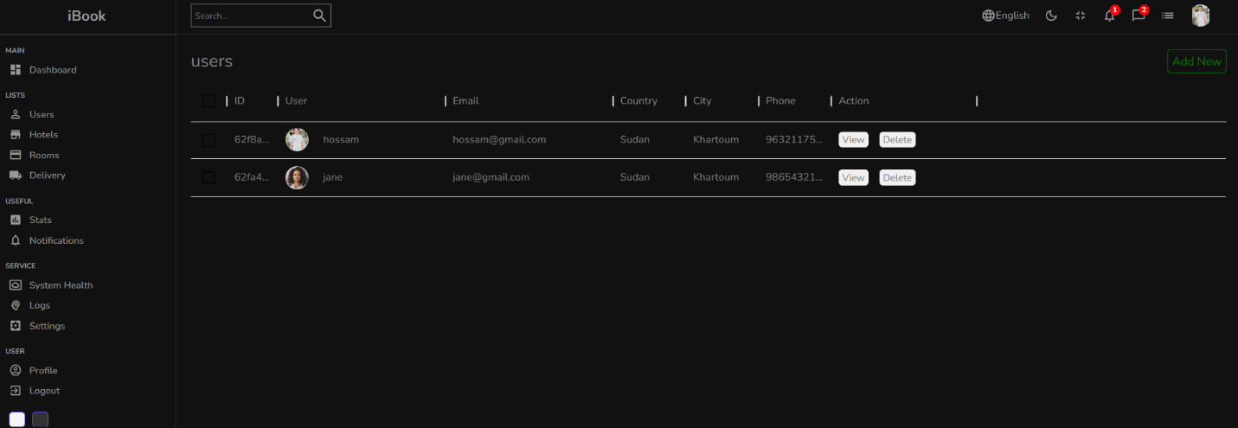

**Admin Dashboard**

**Hotels Page**

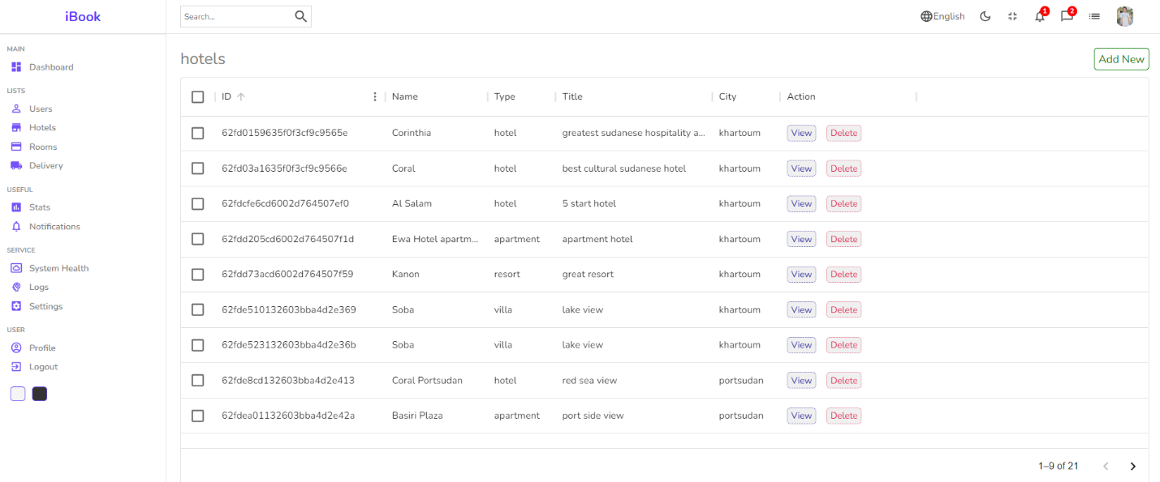

**Admin Dashboard**

**Add new Hotel**

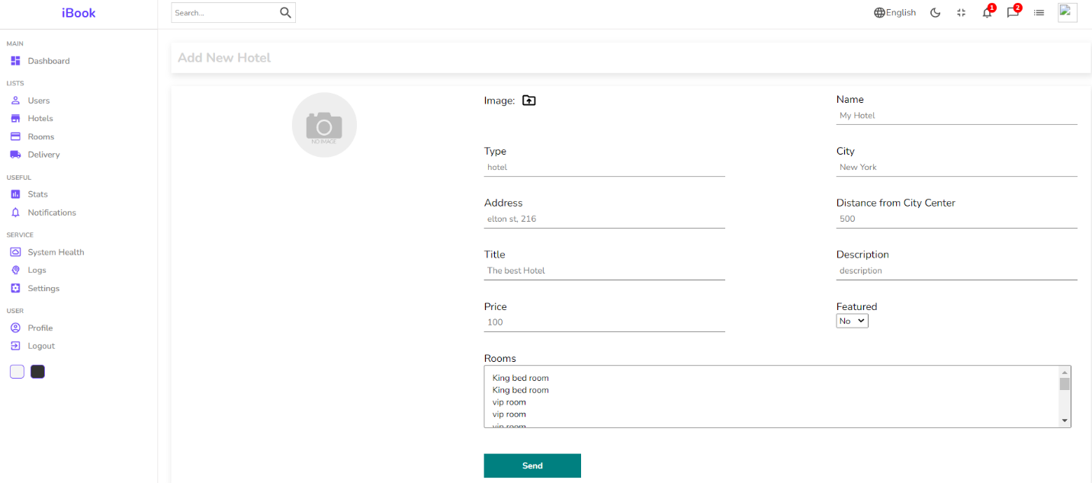

**Admin Dashboard**

**View / Edit Hotel**

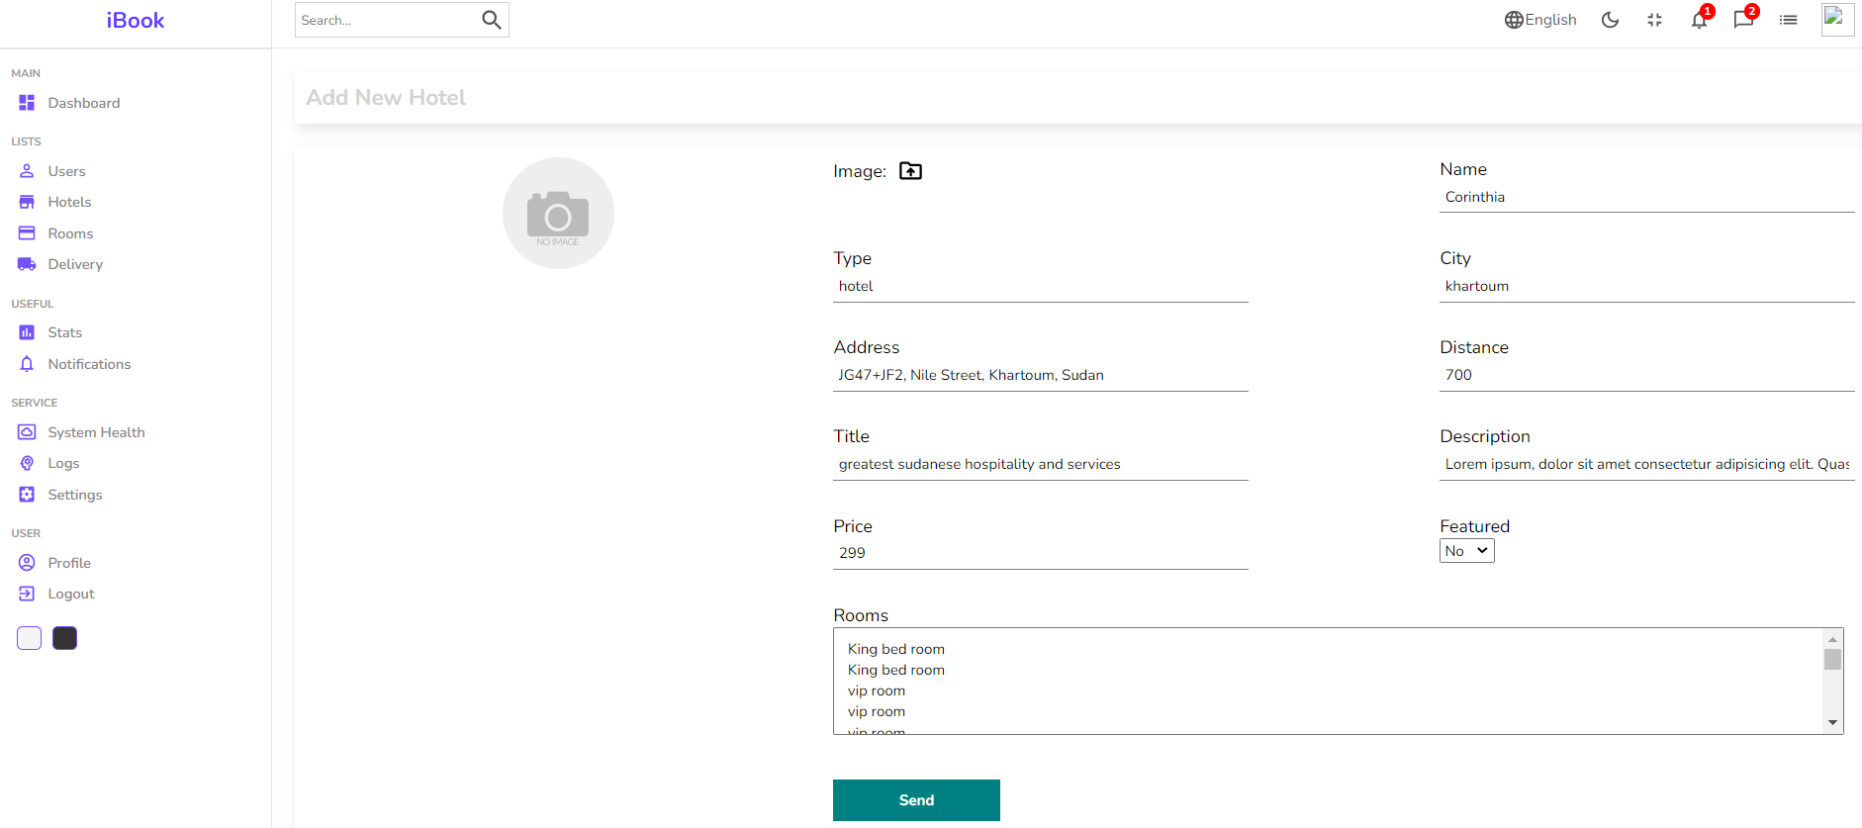

**Admin Dashboard**

**Rooms Page**

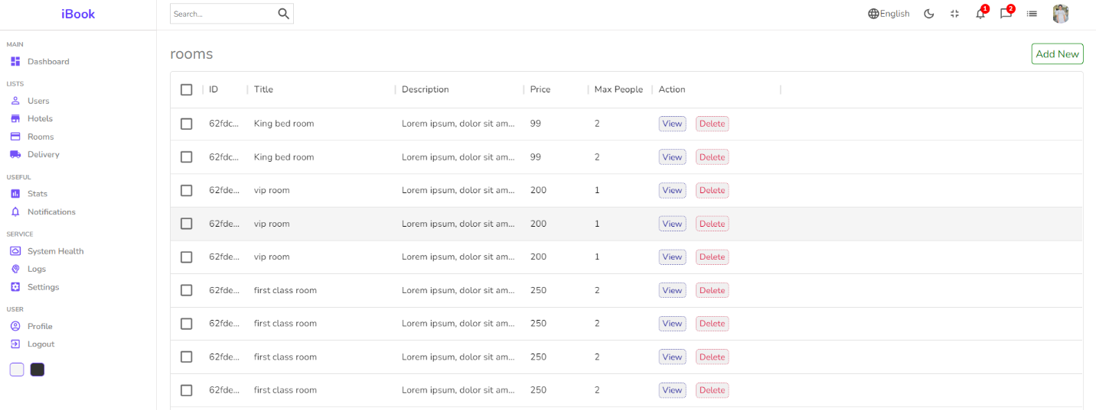

**Admin Dashboard**

**Add new Room**

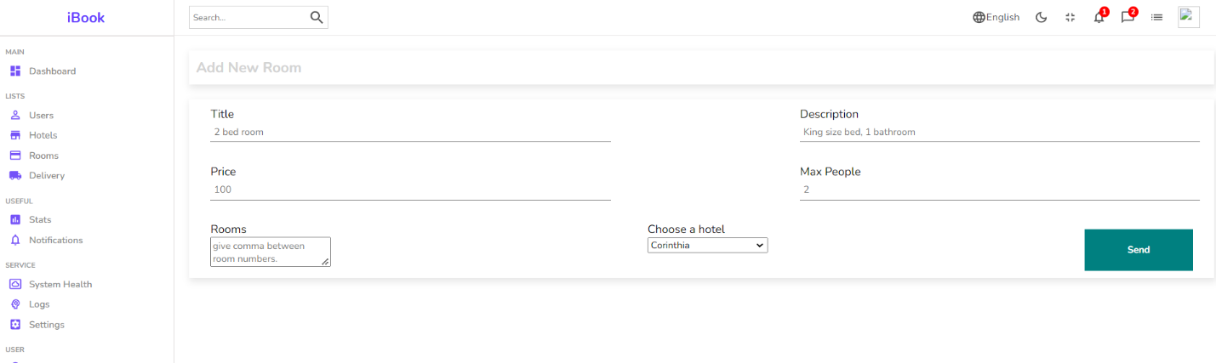

**Admin Dashboard**

**View / Edit Room**



**Client Side**

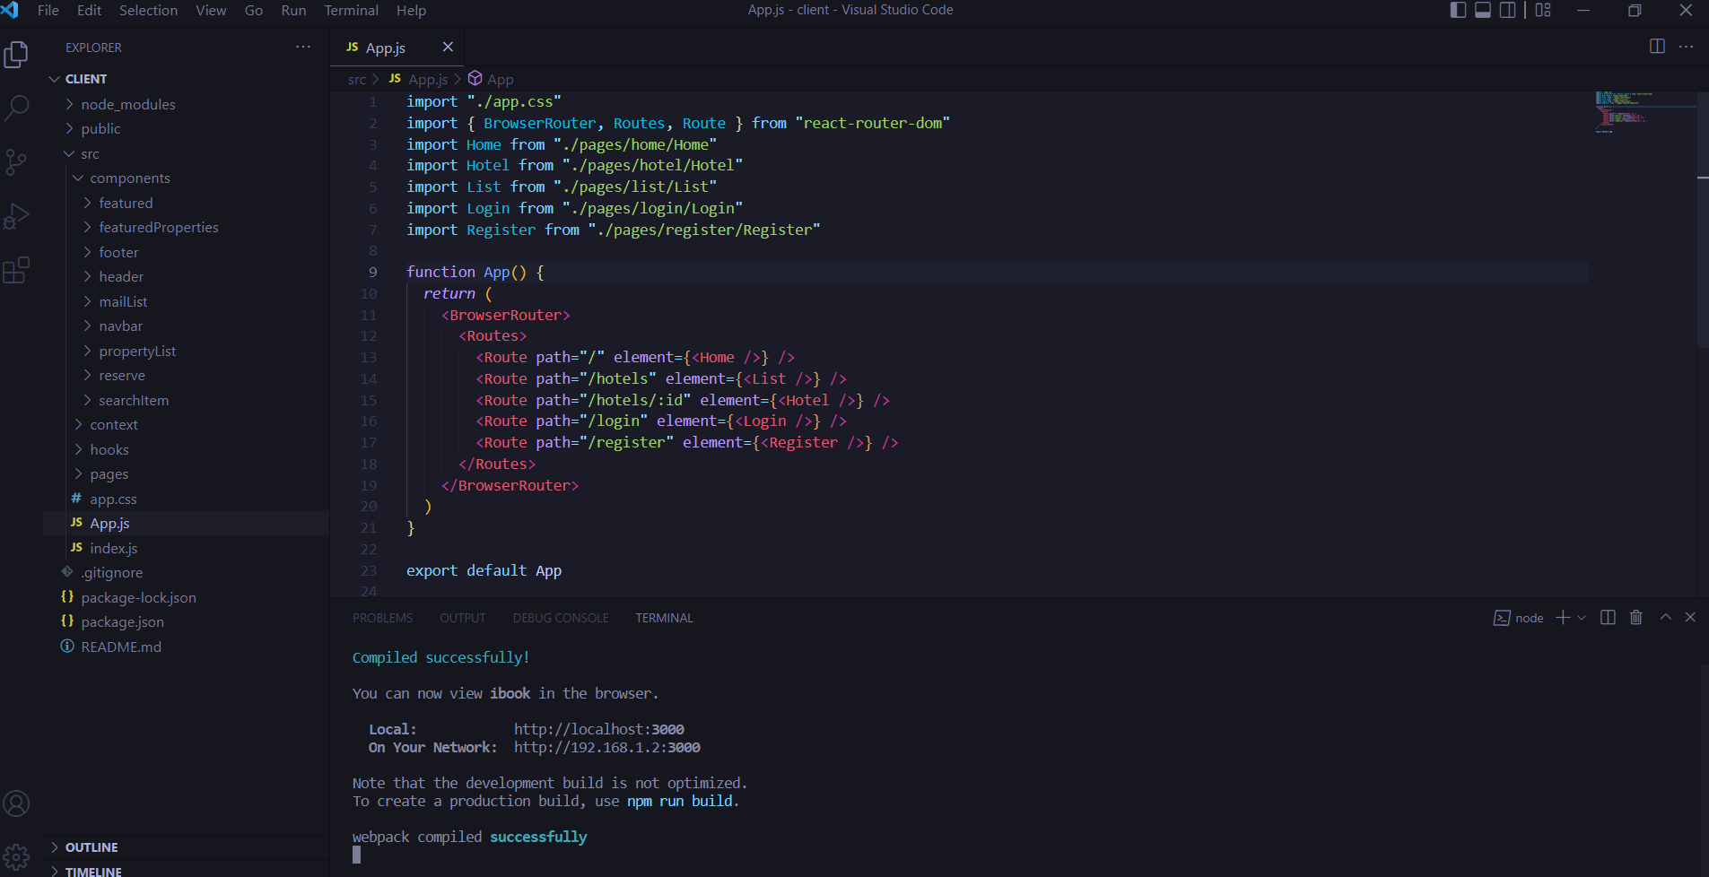

**Admin Dashboard**

**Login page**



**Admin Dashboard**

**Register page**

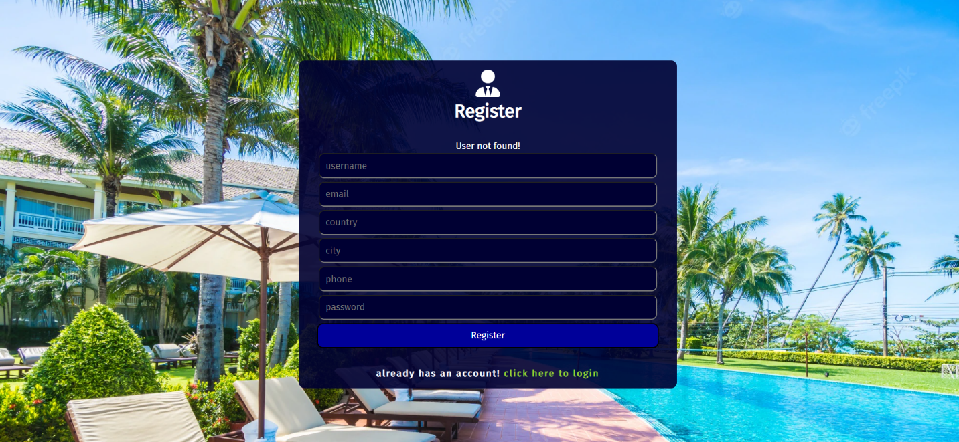

**Admin Dashboard**

**Home page**

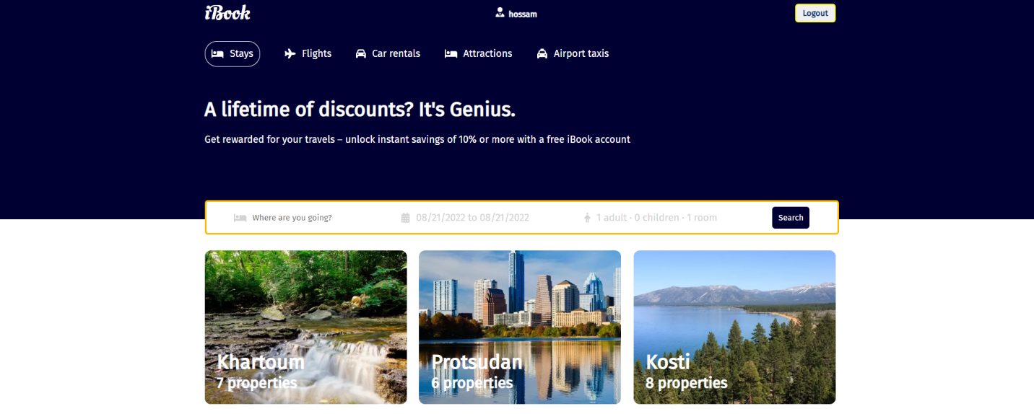

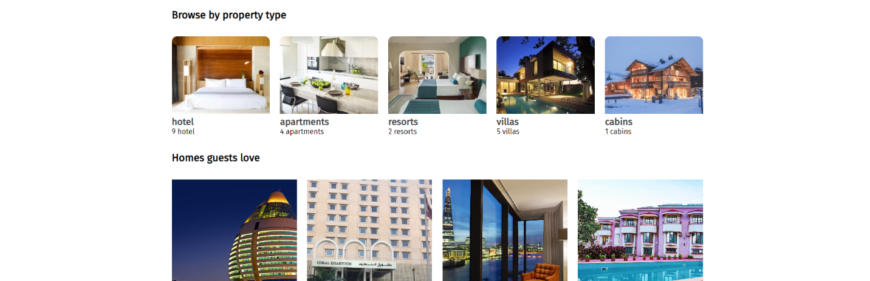

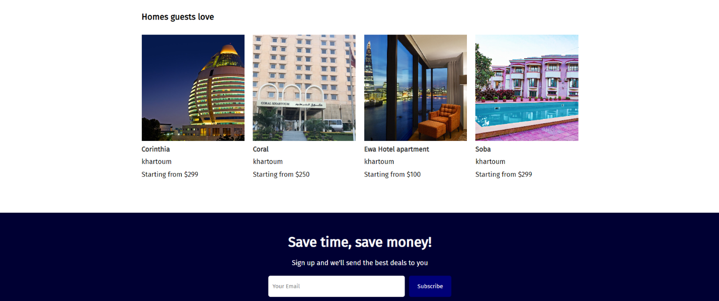

**Admin Dashboard**

**Hotel search**

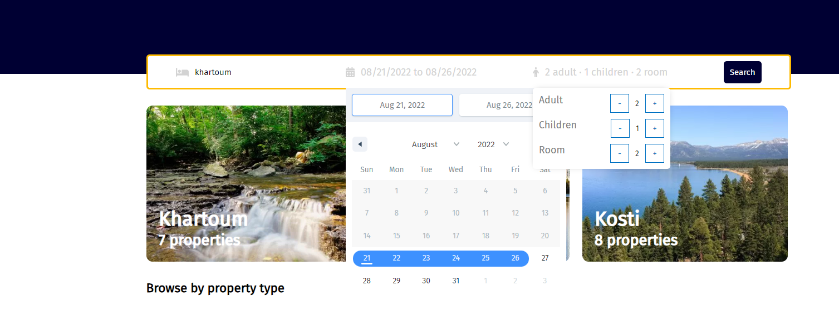

**Admin Dashboard**

**Search result**

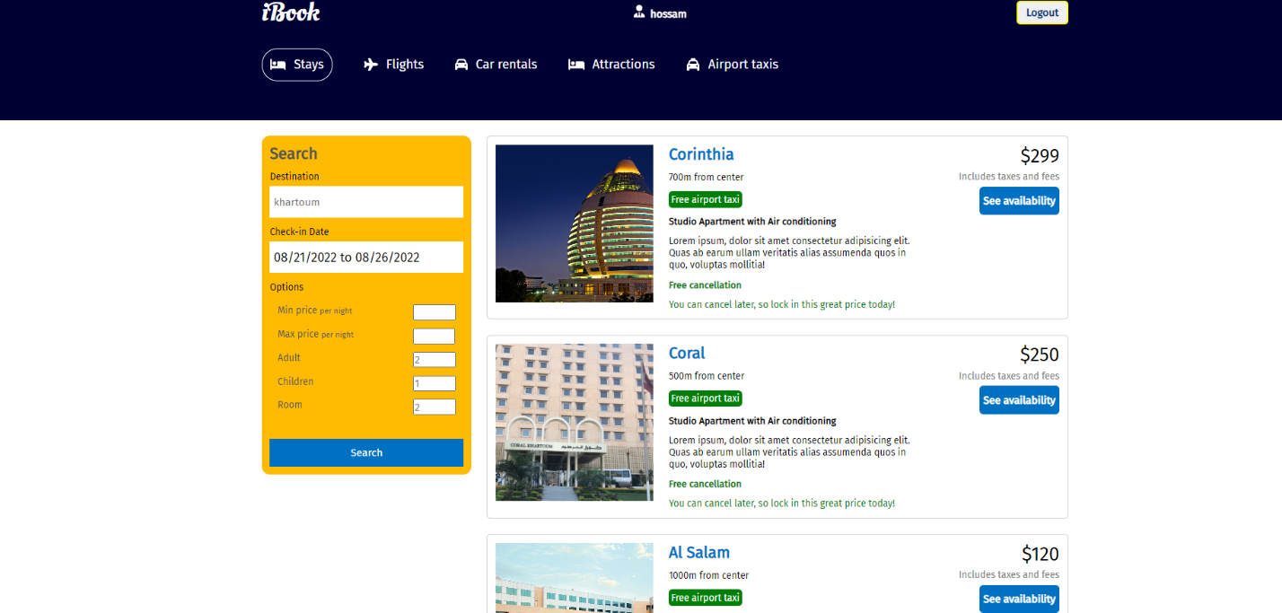

**Admin Dashboard**

**Room reservation**

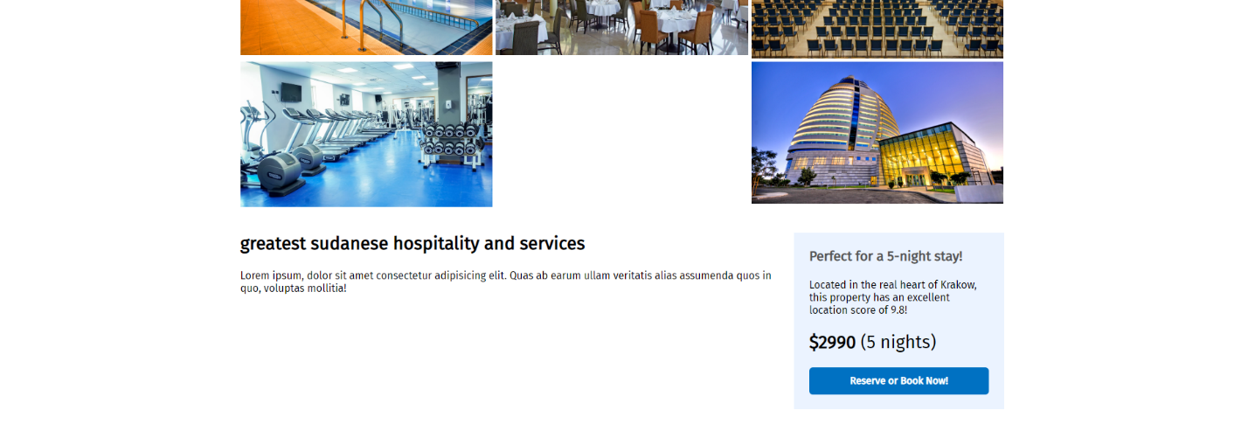

**Admin Dashboard**

**Room checking**

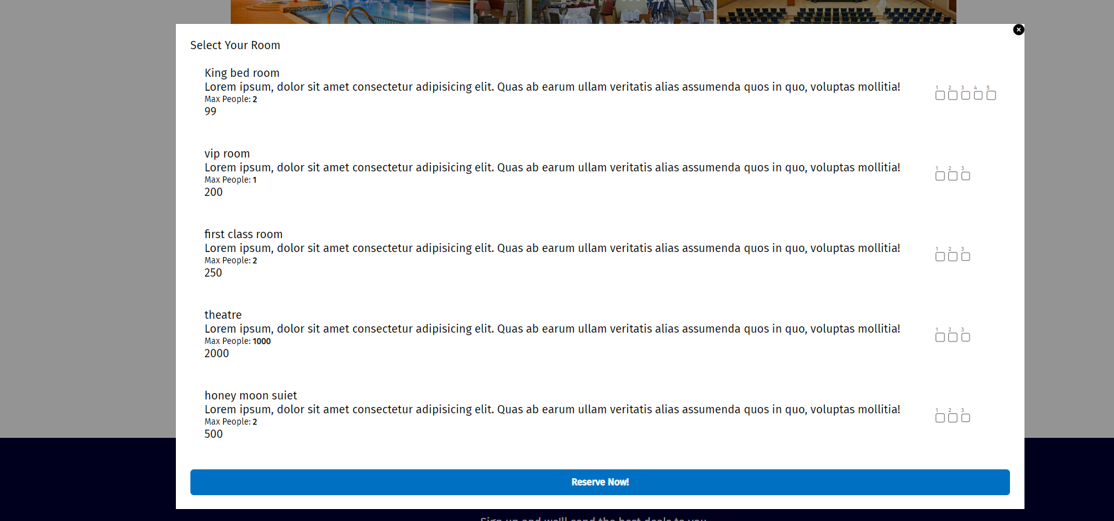

**Admin Dashboard**

**Unavailable rooms**

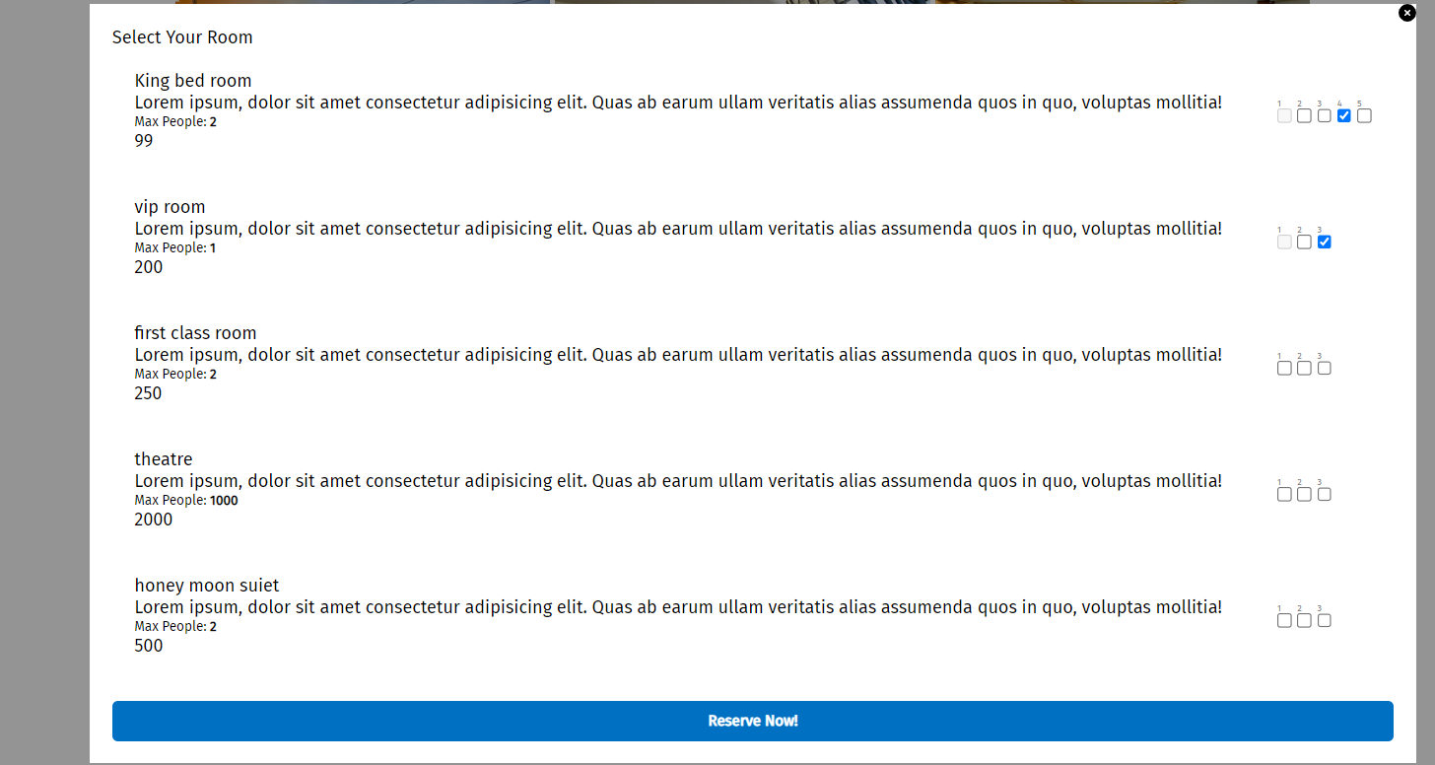

**TEST PLAN**

**TEST PLAN IDENTIFIER:**

Hotel Management System

**INTRODUCTION :**

The main purpose of the test plan for the Hotel Management System is to discuss the testing details of the use cases of the Hotel Management System. The software project test plan also describes the objective, scope and approach of the software testing effort for the Hotel Management System project. The test plan for the Hotel Management System also indicates the personnel responsible for each task and also specifies the risks associated with the test plan.

**OBJECTIVES:**

The main objectives of the test plan for the Hotel Management System are as follows:

• To identify the features of the system that will be tested.

•To identify and define all the activities necessary to prepare for and conduct the testing process on the Hotel Management System.

• To discuss the testing techniques being used to test the Hotel Management System.

**DEFINITIONS:**

The following are some of the terms and definitions that are related to the test plan of the

**Hotel Management System:**

•**Pass/Fail criteria:** Decision rules that are used to determine whether a software item passes or fails a test.

• **Test:** A collection of one or more test cases

• **Test Item:** A software item that is an objective of testing.

•**Test Plan:** A document describing the scope, approach, resources and schedule of the intended testing activities.

• **Test Summary Report:** A document summarizing the testing activities and results.

•**Testing:** The process of analyzing a software item to detect the differences between the existing and required conditions.

**TEST ITEMS :**

This section of the test plan lists all the items of the Hotel Management System project that will be tested:

• Login

• generate bill

• Register

**APPROACH :**

This section of the test plan describes the overall approach for testing the Hotel Management System project. The approach followed for testing the Hotel Management System ensures that the major features of the project are adequately tested. The testing would be carried out on the Hotel Management System while logging into the system as a Hotel manager or a superadmin of the system.

**INTEGRATION TESTING:**

In Integration Testing, the individual software modules are combined and tested as a whole unit. The integration testing generally follows unit testing where each module is tested as a separate unit. The main purpose of the integration testing is to test the functional and performance requirements on the major items of the project.

All the modules of the project developed individually would be combined together and tested as a whole system in the integration testing

**REGRESSION TESTING:**

The Regression Testing is generally done whenever modifications are made to the source code of a project. The Regression Testing can also be defined as the process of testing changes made to the computer program and also makes sure that the older programming still works with the new changes.

So, before any new version of a software product is released, the old test cases for the project will be run against the software with the changes made, to make sure that the old functionalities of the project still work.

**ACCEPTANCE TESTING:**

This testing is generally performed when the project is nearing its end. This test mainly qualifies the project and decides if it will be accepted by the users of the system. The users or the customers of the project are responsible for the test.

**SYSTEM TESTING:**

The system testing is mainly done on the whole integrated system to make sure that the project that has been developed meets all the requirements. The test cases for the system testing will be the combination of unit and integration tests

**TEST CASES:**

The following are the test cases for the Hotel Management System:

**TEST CASE 1 – USER LOGIN**

• **Incorrect Input:** Incorrect username.

•**Pass Criteria:** An appropriate message should be generated to indicate that an invalid username has been typed.

• **Correct Input**: The correct input would be a valid username of the user and a correct password associated with the username which he uses to log in.

**TEST CASE 2 – USER REGISTRATION**

• **Incorrect Input:** Wrong format entered in the input fields for the registration page.

•**Pass Criteria**: An appropriate message should be generated to the user saying that he has entered the wrong format in the specific input field.

•**Correct Input**: The correct input would a correct format entered by the user into the input fields of the registration page.

• **Pass Criteria:** The pass criteria for Hotel Management System.

**TEST CASE 3 – USER REGISTRATION**

• **Incorrect Input:** The data fields left out empty in the registration page.

• **Pass Criteria:** An error message should be generated to the user saying that he has to fill out those fields in order to be registered into the system.

• **Correct Input:** The correct input in this case, would be that the customer would enter the data in all the fields in the registration form.

•**Pass Criteria:** The pass criteria for the system would be that it accepts all the new user details and then registers the user and helps him log into the system.

**TEST CASE 4 – GENERATE BILL**

• **Incorrect Input:** Incorrect input in this case, would be incorrect search criteria entered or incorrect format of data entered into the data entry fields of the generate bill page.

•**Pass criteria**: A message has to be generated to the user indicating the wrong entry that he has made in the fields.

•**Correct Input**: A correct input would be entering the data into the data entry fields in a correct format.

•**Pass Criteria:** The pass criteria for this test case would be that data will be added to the database.and bill will be generated.

**PASS OR FAIL CRITERIA**

The test cases executed on the Hotel Management System will pass if they meet the specific requirements mentioned in the Vision document of the project. A test case is said to fail, if the desired functionality is not satisfied by the system.

**SUSPENSION CRITERIA AND RESUMPTION REQUIREMENTS.**

**SUSPENSION CRITERIA :**

Testing for all the dependant features will be suspended if a test case fails. The failed test case will be logged onto the test log which contains the description for the error.

**RESUMPTION REQUIREMENT :**

The test cases which are not dependant on the case where the bug is reported will be executed in parallel with the bug fixing. Once the failed test case has been taken note of and has been identified and fixed then the testing for the failed test case will resume.

**TEST DELIVERABLES:**

The following documents will be produced after the testing phase for the Hotel Management System has been completed.

• Test Plan

• Test Cases

• Test Log

**CONCLUSION :**

This project is designed to meet the requirements of Online Hotel Management. It has been developed in Javascript & Mas-Access keeping in mind the specifications of the system.

For designing the system we have used simple data flow diagrams.

Overall the project teaches us the essential skills like:

▪ Using system analysis and design techniques like data flow diagram in designing the system.

▪ Understanding the database handling and query processing.

**REFERENCES:**

The following references have been used by me, during all the phases of the project:

1. <https://www.javascript.com/>
2. <https://reactjs.org/>
3. <https://nodejs.org/en/>
4. <https://expressjs.com/>
5. <https://www.w3schools.com/css/>
6. <https://cloud.mongodb.com/v2>
7. <https://sass-lang.com/>
8. <https://www.mongodb.com/cloud/atlas>
9. <https://mui.com/>